AgentCore vs Strand

What is AgentCore?
Amazon Bedrock AgentCore is a complete set of purpose-built services to deploy and operate AI agents securely at scale, using any framework (LangGraph, CrewAI, Strands Agents) or model. It went GA on October 13, 2025. The services can be used together or independently.

Core Services (7 Primitives)

1. AgentCore Runtime
Secure, serverless runtime for deploying AI agents and tools.
- Works with any open-source framework (LangGraph, CrewAI, Strands)
- 8-hour execution windows (much longer than Lambda's 15 min)
- Fast cold starts, true session isolation, 100MB payload limit
- Supports IAM SigV4 and JWT Bearer Token auth
- Supports MCP and A2A protocols
Internal example — AVA (Amazon Virtual Assistant): The HVH Tech team is migrating their hiring chatbot from Bedrock Agents to AgentCore Runtime, processing 500K+ candidate contacts. They deploy a LangGraph agent on Runtime with API Gateway + Lambda in front for custom auth. [1]

2. AgentCore Gateway
Secure way for agents to discover and use tools via MCP protocol.
- Transforms APIs, Lambda functions, and existing services into agent-compatible tools
- Zero infrastructure for service owners
- Multi-auth: IAM, CloudAuth, Midway, Federate
- Cross-network (CORP/PROD) connectivity
Internal example — Fortune (Financial Reporting): The WWASFT team connected their NAWS financial APIs (ECS Fargate + API Gateway) to an agent via AgentCore Gateway, enabling AI-driven PNL data queries without spinning up custom MCP server infrastructure. [2]

3. AgentCore Memory
Managed short-term and long-term memory for context-aware agents.
- Short-term: Multi-turn conversation history (up to 365 days)
- Long-term: Auto-generated summaries, facts, user personalization — searchable semantically
- Shareable across agents and sessions
Internal example: CXRS chat applications use AgentCore Memory for session context, with CreateEvent/ListEvents APIs for short-term and RetrieveMemoryRecords for long-term memory across customer support conversations. [3]

4. AgentCore Identity
Agent identity and access management.
- Compatible with existing IdPs (Federate, OIDC)
- Secure token vault to minimize consent fatigue
- "On behalf of" workflows using OAuth 2.0
- Just-enough access and secure permission delegation
Internal example: CloudAuth-protected agents deployed on Runtime use AgentCore Identity for outbound authorization to call downstream SDO services securely. [4]

5. AgentCore Tools
- Code Interpreter: Securely execute code in isolated sandboxes
- Browser Tool: Cloud-based browser for agents to interact with websites at scale

6. AgentCore Evaluations
Automated assessment of agent/tool performance using LLM-as-a-Judge techniques. Integrates with Strands and LangGraph via OpenTelemetry.

7. AgentCore Policy
Define and enforce security controls using Cedar language (or natural language).
- Intercepts all agent traffic through Gateway
- Fine-grained permissions based on user identity and tool parameters
- Automated reasoning to catch overly permissive/restrictive policies

Quick Start: Deploying an Agent on AgentCore
# 1. Configure with VPC connectivity
agentcore configure --vpc \
--subnets subnet-xxx,subnet-yyy \
--security-groups sg-xxx \
-e your-agent.py --protocol MCP --region us-east-1

# 2. Deploy
agentcore deploy

# 3. Check status
agentcore status
Or via boto3:
import boto3

client = boto3.client('bedrock-agentcore-control', region_name='us-east-1')

response = client.create_agent_runtime(
agentRuntimeName='my-agent',
authorizerConfiguration={
"customJWTAuthorizer": {
"discoveryUrl": "https://your-federate-endpoint/.well-known/openid-configuration",
"allowedAudiences": ["your-client-id"]
}
},
)

Auto-Generate MCP Server from Coral Service (Zero-Code)
mcp-registry create coral-service-mcp \
--id your-service-mcp \
--name 'Your Service MCP Server' \
-mps YourServiceModel-1.0 \
-cps 'YourServiceClientConfig-1.0' \
-vs YourService/development

Internal Amazon Use Cases Summary
Team / Use Case | AgentCore Services Used | What They Do
HVH Tech (AVA) | Runtime, Memory | Hiring chatbot processing 500K+ contacts, migrating from Bedrock Agents
WWASFT (Fortune) | Gateway, Runtime | Financial PNL data queries via agentic AI
CXRS | Memory, Runtime | Customer support chat with session + long-term memory
AWS Marketing | Runtime, Gateway, Identity | Campaign creation agents deployed via CDK with Strands/LangGraph
FAST Template | Runtime, Gateway, Memory | Text-to-SQL data analytics agent with dynamic few-shot examples
CloudAuth teams | Identity, Runtime | Agents calling CloudAuth-protected downstream services

Key Resources
- Wiki: [5]
- AWS Docs: [6]
- BuilderHub Golden Path: [7]
- Slack: #bedrock-agentcore-interest
- MCP Guidance: [8]
The recommended path for internal teams: start with AgentCore Runtime + Gateway if your use case fits, use Strands Agents or LangGraph as the framework, and deploy via CDK.

Assistant
Let me check my memory first for any existing research on AgentCore, then supplement with fresh searches.

User
what is relationship between Strand and LangGraph vs AgentCore? what is difference between IAM, cloudAuth, midway and federate

Assistant

Detailed Comparison
 | Midway | Federate | IAM | CloudAuth
What | Amazon's internal SSO for humans | Amazon's internal OIDC/OAuth identity provider | AWS Identity & Access Management | Amazon's internal service-to-service auth
Who uses it | Employees in browsers | Apps needing token-based human auth | AWS services & resources | Amazon internal (SDO) services
How it works | Cookie-based auth via mwinit | Issues OIDC/JWT tokens | SigV4 signed requests with access keys | mTLS certificates + IAM policies
Scope | Corp network, internal tools | Internal apps, AgentCore inbound auth | All AWS services (public + internal) | Amazon internal services only
Token type | Browser cookie | JWT / Access token | Temporary credentials (STS) | X.509 cert + IAM role
Best for | Web UIs, wikis, internal portals | Modern apps needing OAuth flows, AgentCore identity | AWS API calls, cross-account access | Coral/Smithy service-to-service calls

When to Use What (for AgentCore)
Inbound auth (who can call your agent):
- Federate — Recommended for AgentCore Runtime inbound. Issues OIDC tokens that AgentCore validates.
- IAM SigV4 — If the caller is an AWS service or uses boto3.
- Midway — Not directly supported for AgentCore inbound (requires human in the loop). Use Federate instead.
Outbound auth (your agent calling downstream services):
- CloudAuth — If your agent calls Amazon internal Coral/Smithy services. Agent must be registered as a CloudAuth client.
- IAM — If your agent calls AWS services (S3, DynamoDB, Bedrock, etc.).
- Midway — Avoid for agents. Midway requires human interaction (mwinit), which doesn't work for autonomous agents. Teams like Fortune had to migrate from Midway to IAM auth for this reason.

Practical Example Flow
User (browser)
→ Midway auth → Your Web UI
→ Federate token → AgentCore Runtime (validates JWT)
→ Agent code (Strands/LangGraph)
→ CloudAuth → Internal Coral service (e.g., order lookup)
→ IAM SigV4 → AWS service (e.g., DynamoDB, S3)

Quick Decision Tree
- Human accessing a web app? → Midway (browser) or Federate (token-based)
- Service calling AWS resources? → IAM
- Service calling Amazon internal APIs? → CloudAuth
- Protecting AgentCore Runtime inbound? → Federate (OIDC) or IAM
- Agent calling downstream tools? → CloudAuth (internal) or IAM (AWS)

TL;DR: Strands/LangGraph = your agent's brain (code). AgentCore = your agent's body (infrastructure). And for auth: Midway is for humans in browsers, Federate is for token-based human auth, IAM is for AWS resources, CloudAuth is for Amazon internal service-to-service calls.

Assistant
Great questions — these are two of the most common points of confusion. Let me break both down clearly.

1. Strands / LangGraph vs AgentCore: Relationship
Think of it as application code vs infrastructure:

Assistant

Assistant

The Key Distinction
 | Strands / LangGraph | AgentCore
What it is | Agent framework (SDK/library) | Infrastructure platform (managed services)
Analogy | Your Flask/Django app code | EC2/Lambda/ECS that runs it
Responsibility | Agent logic, tool calling, prompt chaining, multi-agent orchestration, graph workflows | Hosting, scaling, auth, networking, memory, observability, security policies
Runs where? | Inside AgentCore Runtime (or Lambda, ECS, your laptop) | AWS managed infrastructure
You write | Python code using the SDK | Configuration, CDK, CLI commands

Strands vs LangGraph
 | Strands Agents | LangGraph
Built by | AWS/Amazon | LangChain (3rd party)
Philosophy | Model-driven — LLM decides what to do next | Graph-driven — you define explicit state machine / DAG
Best for | Simple-to-moderate agents where the LLM can drive the flow | Complex multi-step workflows needing deterministic control, human-in-the-loop, checkpoints
Multi-agent | Supports A2A protocol | Graph-based orchestration with handoffs
Language | Python | Python, JavaScript
Amazon recommendation | Preferred for new projects (AWS-native) | Supported, good for complex workflows
Bottom line: You pick Strands or LangGraph to write your agent, then deploy it on AgentCore Runtime. AgentCore doesn't care which framework you use — it's framework-agnostic.

2. IAM vs CloudAuth vs Midway vs Federate
These are four different authentication/authorization systems at Amazon, each serving different contexts:
Midway | Federate | IAM | CloudAuth
What | Amazon's internal SSO for humans | Amazon's internal OIDC/OAuth identity provider | AWS Identity & Access Management | Amazon's internal service-to-service auth
Who uses it | Employees in browsers | Apps needing token-based human auth | AWS services & resources | Amazon internal (SDO) services
How it works | Cookie-based auth via mwinit | Issues OIDC/JWT tokens | SigV4 signed requests with access keys | mTLS certificates + IAM policies
Scope | Corp network, internal tools | Internal apps, AgentCore inbound auth | All AWS services (public + internal) | Amazon internal services only
Token type | Browser cookie | JWT / Access token | Temporary credentials (STS) | X.509 cert + IAM role
Best for | Web UIs, wikis, internal portals | Modern apps needing OAuth flows, AgentCore identity | AWS API calls, cross-account access | Coral/Smithy service-to-service calls

When to Use What (for AgentCore)
Inbound auth (who can call your agent):
- Federate — Recommended for AgentCore Runtime inbound. Issues OIDC tokens that AgentCore validates.
- IAM SigV4 — If the caller is an AWS service or uses boto3.
- Midway — Not directly supported for AgentCore inbound (requires human in the loop). Use Federate instead.
Outbound auth (your agent calling downstream services):
- CloudAuth — If your agent calls Amazon internal Coral/Smithy services. Agent must be registered as a CloudAuth client.
- IAM — If your agent calls AWS services (S3, DynamoDB, Bedrock, etc.).
- Midway — Avoid for agents. Midway requires human interaction (mwinit), which doesn't work for autonomous agents. Teams like Fortune had to migrate from Midway to IAM auth for this reason.

Practical Example Flow
Raw code
User (browser)
→ Midway auth
→ Your Web UI
→ Federate token
→ AgentCore Runtime (validates JWT) → Agent code (Strands/LangGraph)
→ CloudAuth → Internal Coral service (e.g., order lookup)
→ IAM SigV4 → AWS service (e.g., DynamoDB, S3)

Quick Decision Tree
- Human accessing a web app? → Midway (browser) or Federate (token-based)
- Service calling AWS resources? → IAM
- Service calling Amazon internal APIs? → CloudAuth
- Protecting AgentCore Runtime inbound? → Federate (OIDC) or IAM
- Agent calling downstream tools? → CloudAuth (internal) or IAM (AWS)

Strands/LangGraph = your agent's brain (code). AgentCore = your agent's body (infrastructure). And for auth: Midway is for humans in browsers, Federate is for token-based human auth, IAM is for AWS resources, CloudAuth is for Amazon internal service-to-service calls.

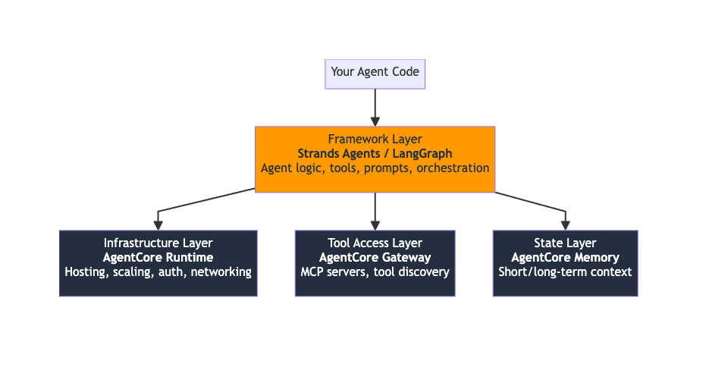

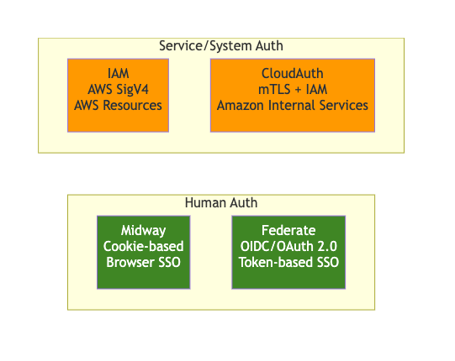

What Gateway Actually Does
Capability | Without Gateway | With Gateway
Expose an API as a tool | Write custom MCP server, handle serialization, deploy infrastructure | Point Gateway at your Lambda/API → done
Auth | Implement auth per tool yourself | Built-in IAM, CloudAuth, Federate support
Tool discovery | Agent must be hardcoded to know about tools | Agent queries Gateway, discovers tools dynamically
Security policies | Custom code in each tool | AgentCore Policy (Cedar) intercepts all traffic at Gateway
Scaling | You manage it | Fully managed
Cross-network | Complex VPC/proxy setup | Built-in CORP↔PROD connectivity

The Three Key Jobs
- Tool Transformation — Takes your existing Lambda functions, Coral services, or REST APIs and wraps them as MCP-compatible tools without code changes
- Tool Discovery — Agents can search "what tools are available?" and Gateway returns a catalog. Think of it as a service registry for AI tools.
- Security Boundary — Every agent→tool call passes through Gateway, where AgentCore Policy evaluates Cedar policies before allowing access. This is the enforcement point.

Concrete Example
Say your team has a Lambda that looks up order status. Without Gateway:
# You'd write a custom MCP server (~100+ lines)
# Handle auth, serialization, error handling, deployment...
With Gateway:
import boto3

client = boto3.client('bedrock-agentcore-control')

# Create a gateway with your Lambda as a target
client.create_gateway(
gatewayName='order-tools-gateway',
protocolType='MCP',
authorizerConfiguration={...},
)

# Add your Lambda as a tool target
client.create_gateway_target(
gatewayIdentifier='order-tools-gateway',
name='order-status',
targetConfiguration={
'lambdaTarget': {
'lambdaArn': 'arn:aws:lambda:us-east-1:123456:function:OrderStatus'
}
}
)
Now any agent with Gateway access can discover and call order-status — zero MCP server code written.

Gateway vs MCP Server (When to Use Which)
Scenario | Use
You have existing Lambda/Coral/REST APIs | Gateway — zero code, just configure
You need custom logic, complex transformations, or non-standard protocols | Custom MCP server deployed on Runtime
You want centralized auth + policy enforcement across many tools | Gateway — it's the single chokepoint
You're building a local dev tool | Local MCP server (stdio) — Gateway is overkill
Think of Gateway as an API Gateway (like AWS API Gateway), but specifically designed for the MCP protocol and AI agent tool calling. It's the managed "front door" that sits between your agents and your tools.

Assistant

AgentCore Gateway — Purpose
AgentCore Gateway solves a specific problem: how does your AI agent securely discover and call tools/APIs?
Without Gateway, you'd need to manually write integration code, handle auth, manage infrastructure, and maintain MCP servers for every tool your agent needs. Gateway eliminates all of that.

